

Microsoft Word 2016 Basic Authoring and Testing Guide

Section 508 Accessibility Guidance

Accessible Electronic Document Community of Practice (AED COP)

October 2018

Contents

Document Formatting 2

1. Is the file name descriptive, is the file in the .docx format, and is the file not protected? 2

Text Formatting 4

2. Do document headings use the MS Word heading styles? 4

3. Are lists formatted correctly? 5

4. Are columns of content formatted correctly? 6

5. Are layout tables formatted correctly? 8

6. Is text formatted for the intended language? 9

7. Are link names descriptive? 11

Object Formatting 12

8. Is vital information in headers, footers, and watermarks duplicated in the document? 12

9. Did you use built-in features to create data tables? 12

10. Do images and other objects have alternative text? 15

11. Are images, objects, and text boxes in line with the text? 16

Color Formatting 17

[12. Are colors and other visual characteristics that convey information   
also described with text? 17](#_Toc528312309)

13. Is the contrast ratio between text and background sufficient? 18

Miscellaneous 20

14. Are there corresponding descriptions of your embedded files and are they accurate? 20

15. Did you avoid forms while using MS Word 2016? 21

16. Did you exclude flashing objects? 21

Index of Figures 22

Index of Tables 22

Microsoft Word 2016  
Basic Authoring and Testing Guide

# Document Formatting

## Is the file name descriptive, is the file in the .docx format, and is the file not protected?

How to test

**Instruction 1:** Look at the filename in Windows Explorer or the title bar in MS Word. An example of a non-descriptive file name is “Document1.” An example of a descriptive filename is “MSWord_Checklist.” The file must be in the “*.docx” format for accessibility testing to be possible.

**Note:** If the file name extension is not displayed, open your documents folder in Windows Explorer, select “View” and enable the checkmark for “File name extensions.”

**Figure 1:** “Save As” options window

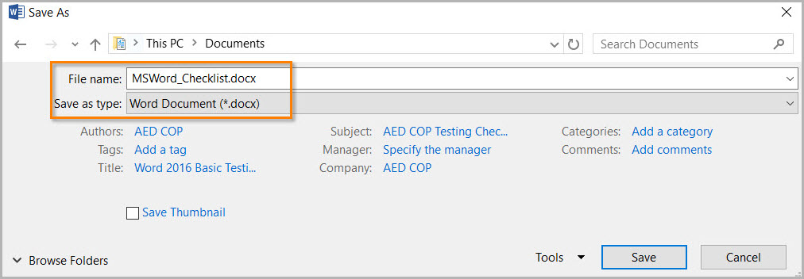

**Test A:** Is the filename descriptive and does it identify the document or its purpose? If not, the document fails this test.

**Test B:** Is the file in “Word Document (.docx)” format? If not, the document fails this test.

**Instruction 2:** Select the “Review tab>Restrict Editing” and look to see if the “Stop Protection” button appears at the bottom of the “Restrict Editing” pane. If the “Restrict Editing” pane shows options 1, 2, and 3, then restricted editing is turned off. Document protections limit the ability to test for accessibility and can make portions or the entire document inaccessible.

**Figure 2:** Restrict Editing pane options and protected enabled views

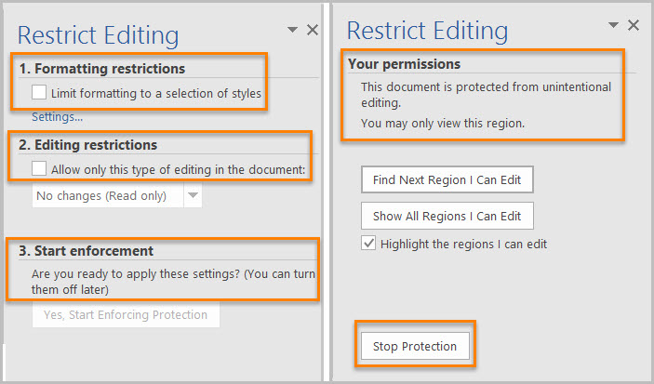

**Test C:** Does the “Restrict Editing” pane show options 1, 2, and 3? If not, the document fails this test.

How to author for accessibility

A descriptive filename that identifies the document or its purpose helps everyone (including people with disabilities) locate, open, and switch between documents. In addition, the document must be in a “.docx” format because these authoring and testing instructions will only work if the file is in the “.docx” file format. Document restrictions limit or prevent users of assistive technology from reading or editing the document. If you must use document restrictions, turn them off during testing and then ensure assistive technology users have access to the password.

Select “File tab>Save As”

* Save as type: “Word Document (*.docx)”.
* Save the document with a descriptive filename.

# Text Formatting

## Do document headings use the MS Word heading styles?

How to test

**Instruction:** Open the “Navigation pane (Ctrl+F)” and select the “Headings” tab.

**Test A:** Do the headings in the “Navigation pane” mirror the headings you see in the document? If not, the document fails this test.

**Test B:** Do the headings you see in the “Navigation pane” match the visual outline of your document (i.e. the same hierarchy)? If not, the document fails this test.

**Figure 3:** Matching headings displayed in Navigation Pane and document

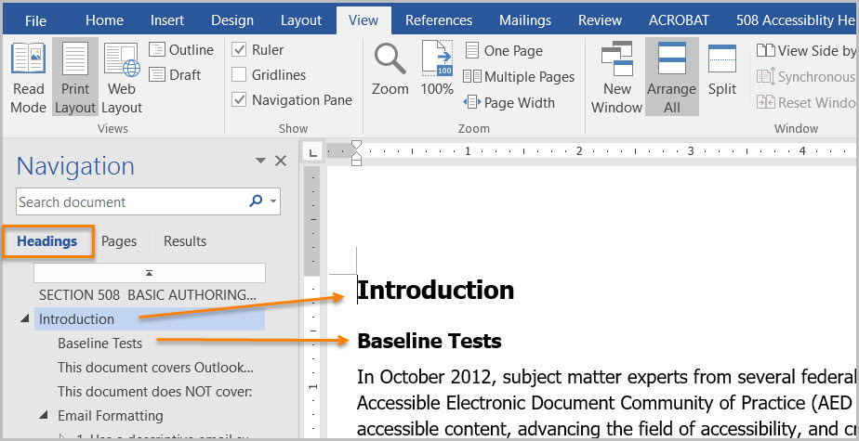

How to author for accessibility

Headings organize content and make finding information easier. Assistive technology cannot infer meaning if you just format the text (such as increased font size, bold, or underlined text). Heading styles create a structure that assistive technology can quickly access and aid document navigation based on the heading levels.

Select “Home tab>Styles” (or “Ctrl+Alt+Shift+S” to open the “Styles pane”) and apply heading styles to the headings in your document.

**Figure 4:** Styles Pane and options window with Heading 1 Style selected

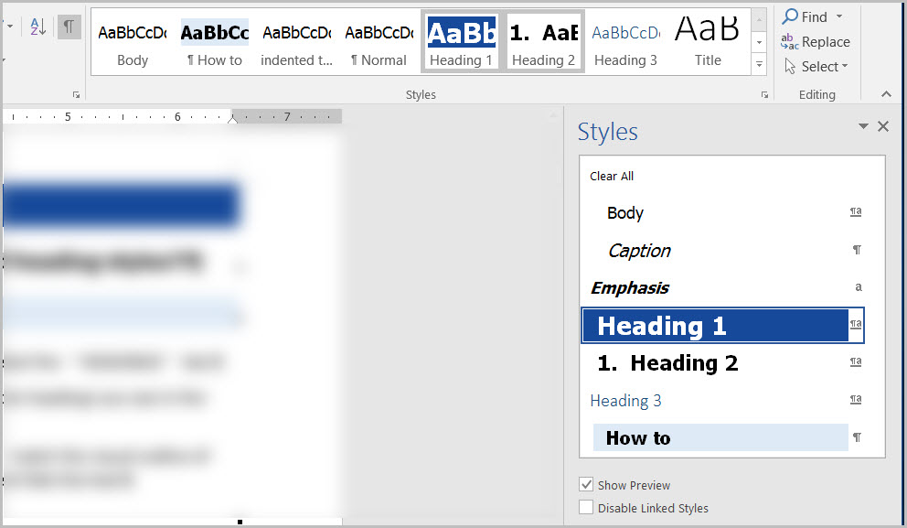

You can:

* Select the heading style you want and then type your heading, or
* Type your heading, place your cursor anywhere within the heading, and then select the heading style you want to use.

If you have different heading levels (such as chapter, article, section, topic, etc.), then you must use a different style for each heading type. You can modify styles to create the look and feel you want in your document.

## Are lists formatted correctly?

How to test

**Instruction:** Place your cursor on a list item. Open the “Reveal Formatting pane (Shift+F1).”

**Figure 5:** List option displayed under Bullets and Numbering

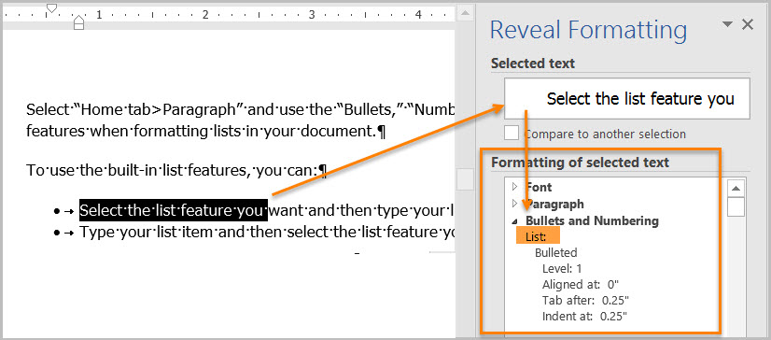

**Test:** Is the “List” option visible under “Bullets and Numbering”? If not, the document fails this test.

How to author for accessibility

Lists organize and structure content. Assistive technology users cannot infer meaning if you just format with tabs, a dash, or a number. Using built-in list features applies the formatting that assistive technology needs to both identify and present lists to users with disabilities.

Select “Home tab>Paragraph” and use the “Bullets,” “Numbering,” or “Multilevel List” features when formatting lists in your document.

To use the built-in list features, you can:

* Select the list feature you want and then type your list item, or
* Type your list item and then select the list feature you want to use.

**Figure 6:** Paragraph tab displaying options for bulleted, numbered and multilevel lists

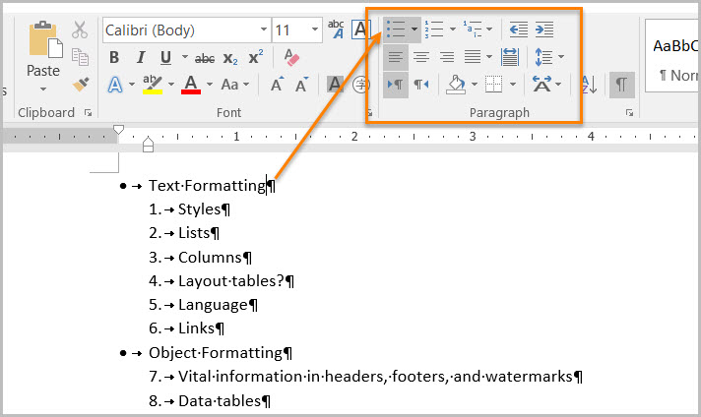

## Are columns of content formatted correctly?

How to test

**Note:** If content does not appear in columns, you do not need to perform this test.

**Instruction:** Place your cursor on content that appears to be formatted in columns (similar to how a newspaper article will span multiple columns). Open the “Reveal Formatting pane (Shift+F1)” and expand “Section” by selecting the arrow sign.

**Figure 7:** Number of Columns displayed under Section>Columns option

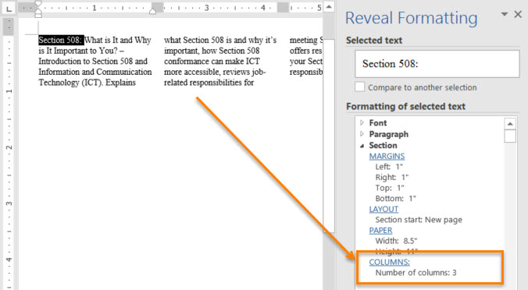

**Test:** Are “Columns:” listed under “Section?” If not, the document fails this test.

How to author for accessibility

Screen readers and assistive technology cannot read information in the correct reading order when using tabs or spaces to separate content into columns.

Select “Layout tab>Page Setup>Columns” when creating columns in your document.

**Figure 8:** Columns menu set to Two columns option

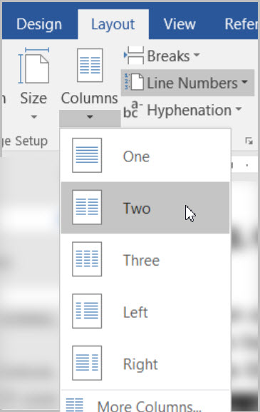

To use the built-in column feature:

* Select content you want to format.
* Select “Columns.”
* Select the number of columns you want.

## Are layout tables formatted correctly?

How to test

**Instruction 1:** Layout tables arrange content on the page. Place your cursor on the first cell of your layout table. Use your “Tab” key to navigate through the table.

**Test A:** Does the tab order match the visual layout? If not, the document fails this test.

**Instruction 2:** “Right click” or “Shift+F10” inside a layout table and select “Table Properties>Text Wrapping.”

**Test B**: Is “None” selected? If not, the document fails this test.

**Figure 9:** Table Properties Table tab displaying Text wrapping set to “None”

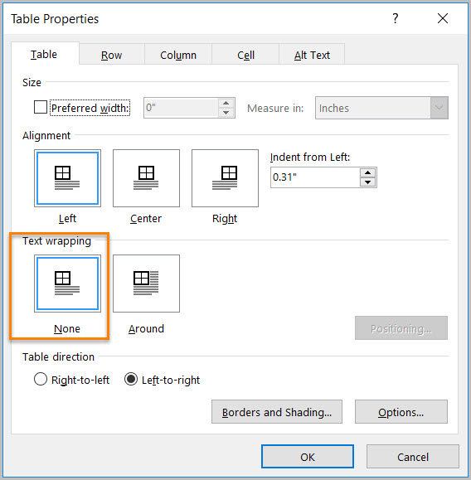

How to author for accessibility

Layout Tables create a structure that screen readers and assistive technology can use to read information in the correct order (left to right then top to bottom). If the table is formatted to allow text to wrap around the table, assistive technology users will have difficulty finding the wrapped text on the page.

To create a table:

* Select “Insert tab>Table”
* Select the desired number of columns and rows.
* Text wrapping is automatically set to “None.”

**Figure 10:** Insert Table menu with a 4x3 table option selected

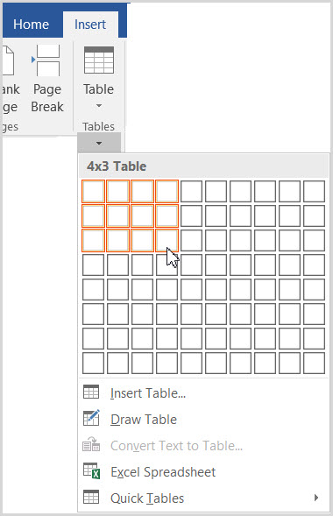

## Is text formatted for the intended language?

How to test

**Note:** If the document only uses one language, you do not have to perform this test.

**Instruction:** If the document contains words or phrases in a language other than the predominant language, place your cursor on that text. Open the “Reveal Formatting pane (Shift+F1)” and look under “Language.”

**Figure 11:** Korean Language displayed under Font>Language formatting option

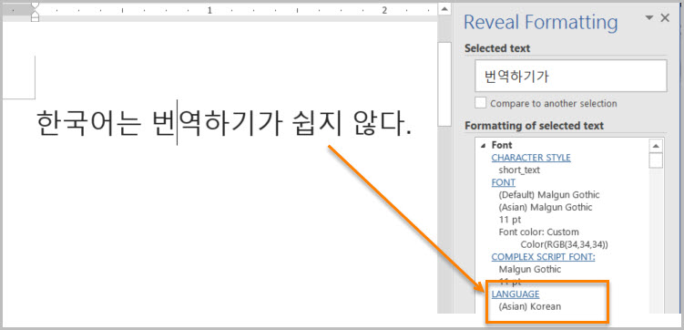

**Test:** Is the text formatted in the correct language? If not, the document fails this test.

How to author for accessibility

A document can contain sections written in different languages. Assistive technology cannot infer the correct pronunciation from just text, so text must be formatted in the correct language.

Select “Review tab>Language>Set Proofing Language.”

**Figure 12:** Language window with Korean language option selected

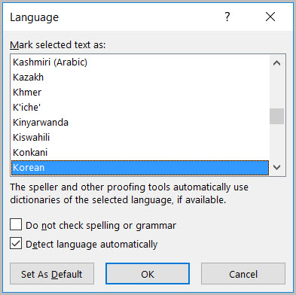

To set a different language, you:

* Select text written in a different language.
* Select “Review tab>Language>Set Proofing Language.”
* Select the appropriate language from the list.

## Are link names descriptive?

How to test

**Test:** Do links have meaningful names that describe their destination, function, and/or purpose or are these determinable within context? If not, the document fails this test.

Uniquely Named Link:  
www.section508.gov

Link Determinable within context:  
[Get My Section 508 Questions Answered](https://section508.gov/content/help-and-faq)

An unclear link name with no context:  
[click here](https://www.opm.gov/)

How to author for accessibility

Assistive technology users rely on meaningful names to determine the destination, function, or purpose of links. For example, multiple “click here” links confuse assistive technology users because the name for each link is the same, while the destinations may be different.

Naming and creating links:

* To edit the name of a link, place your cursor on the link and edit the text.   
  **Note:** deleting the last character in the link name will remove the link.
* To create a hyperlink, select or type the hyperlink text and either right click and select “Hyperlink” or use “Ctrl+K” to open the “Insert Hyperlink” configuration window. Specify/verify the “Text to display” and the “Address” for the link and its destination, and select “OK.”

**Figure 13:** Insert Hyperlink configuration window

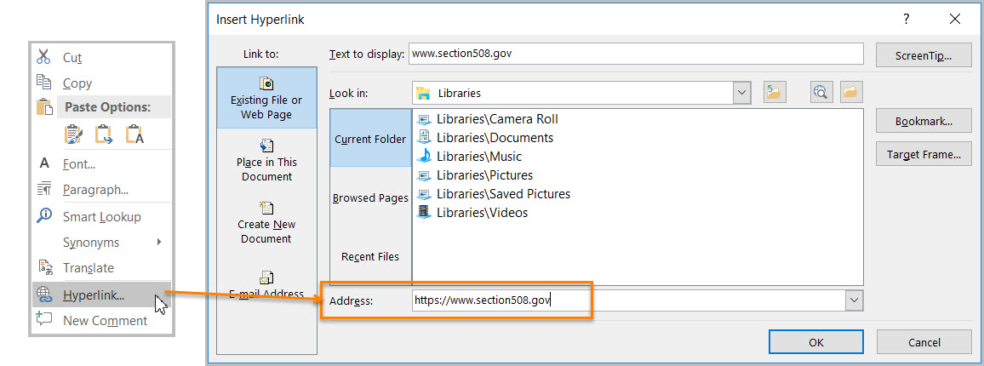

# Object Formatting

## Is vital information in headers, footers, and watermarks duplicated in the document?

How to test

**Instruction:** Look for vital information in headers, footers, and watermarks (e.g. Respond by X Date, CONFIDENTIAL, or Do Not Distribute).

**Test:** Is the vital information duplicated near the beginning of the document? If not, the document fails this test.

How to author for accessibility

Assistive technology does not automatically read information in headers, footers, and watermarks, so you need to duplicate any vital information at or near the start of the related information.

**Figure 14:** Example of vital information in a header repeated in the body of the document

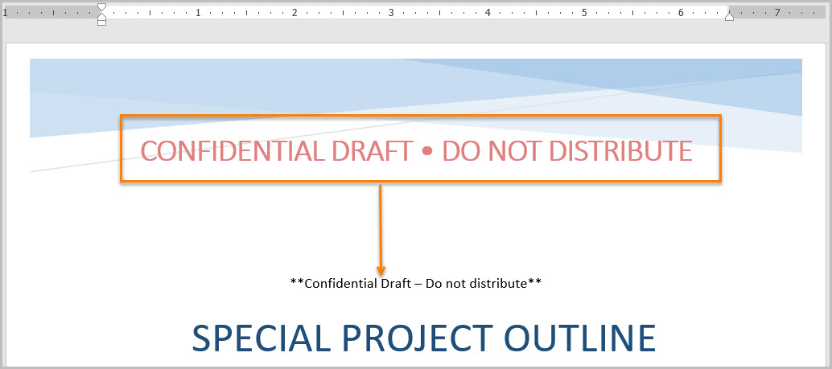

## Did you use built-in features to create data tables?

How to test

**Instruction 1:** Select a table and see if the “Picture Tools” tab shows up in the Ribbon instead of the “Table Tools” tab. If the “Picture Tools” tab shows in the Ribbon, then the table is a picture.

**Test A**: Is the document free of pictures of tables? If not, the document fails this test.

**Instruction 2:** Place your cursor on a table, select “Table Tools>Layout tab>Table group>View Gridlines” button, and look for table cells that are merged or split.

**Test B:** Are tables free of merged or split cells? If not, the document fails this test.

**Figure 15:** Complex table with merged and split cells

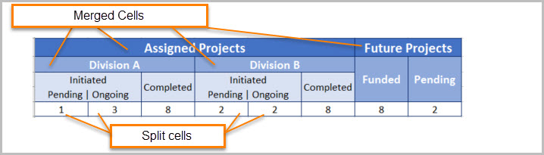

**Instruction 3:** Place your cursor on any cell of a “Header Row.” Open the “Reveal Formatting pane (Shift+F1)” and look under “Table.” If the header row is not set, ‘Repeat as header row’ will not show up in the “Reveal Formatting” pane under “Table>Row.”

**Test C:** Is “Repeat as header row” identified? If not, the document fails this test.

**Figure 16:** Table Properties with Repeat Header Row setting selected

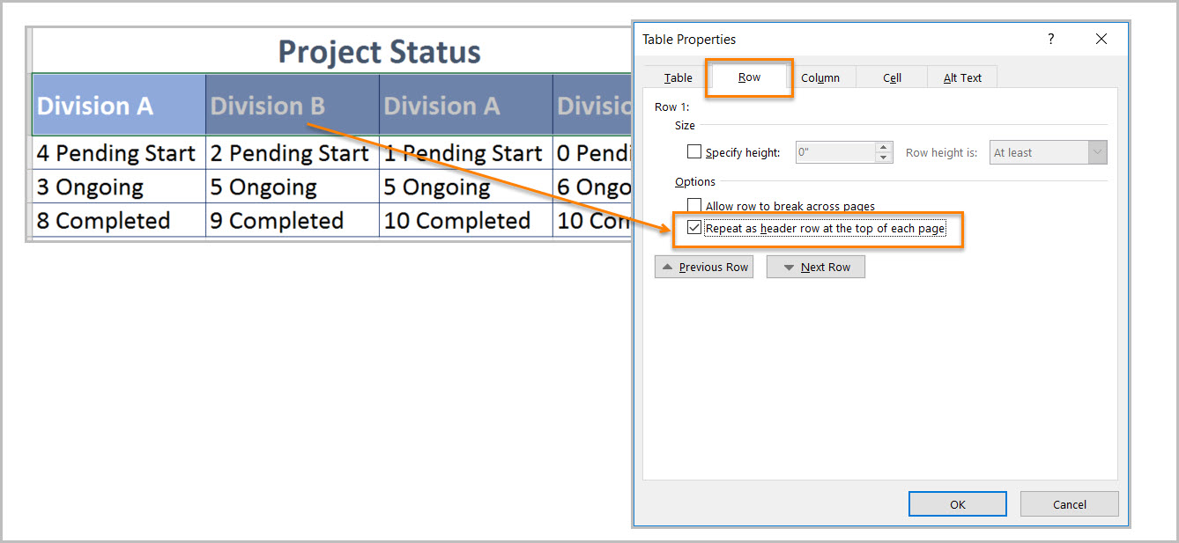

**Instruction 4:** Place your cursor on a table, “right click” or “Shift+F10,” and select “Table Properties>Table tab>Text Wrapping.”

**Test D:** Is “Text Wrapping” set to “None”? If not, the document fails this test.

**Figure 17:** Table Properties window with Text wrapping set to “None”

A screenshot of a cell phone

Description generated with very high confidence

How to author for accessibility

Assistive technology users need to identify column headers in data tables so the user can understand the association between table cells and their respective headers.

Select “Insert tab>Table.”

To create an accessible data table:

* Select the number of columns and rows desired.
* Do not merge or split cells.
* Place the cursor on the first row, “right click” or “Shift+F10,” and select “Table Properties>Row tab>Repeat as header row” button.

**Note:** If you need to create complex data tables (data tables with more than one header row, one or more header column, and/or merged or split cells), then you must convert the document to an accessible format (i.e. a PDF document remediated for accessibility). Complex data tables cannot be made accessible in MS Word.

## Do images and other objects have alternative text?

How to test

**Instruction 1:** Select an image or object that conveys meaning, “right click (or Shift+F10)>Format Picture (Note: could say Format Object, Format Shape, etc.)>Layout & Properties icon>Alt Text,” and read the “Description” field. Also, look for a caption or a description of the image or object in nearby text.

**Test A:** Does the image/object/shape have descriptive text as alt text, a caption, or is it described in the surrounding text? If not, the document fails this test.

**Figure 18:** Format Picture – Alt Text Options

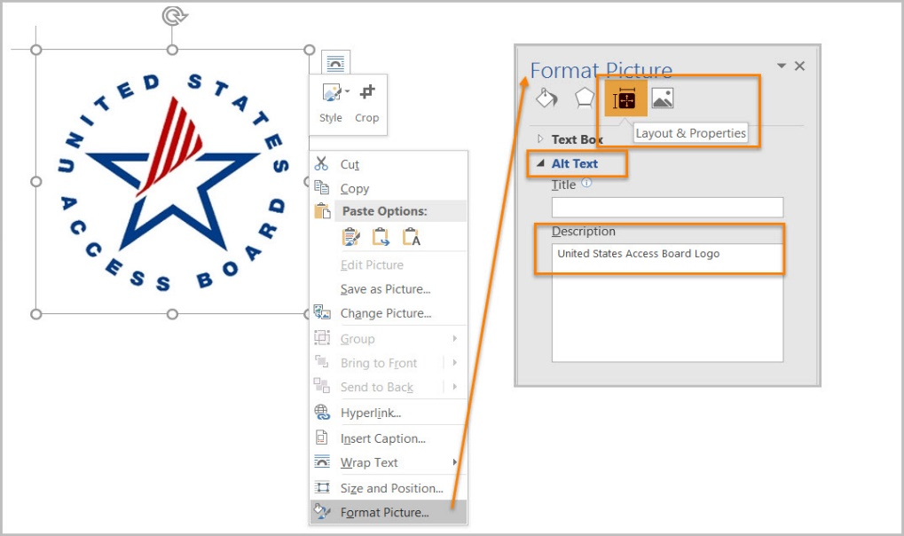

**Instruction 2:** Select an image or object that is just for decoration, “right click (or Shift+F10)>Format Picture (Note: could say Format Object, Format Shape, etc.)>Layout & Properties icon>Alt Text,” and read the “Description” field.

**Test B:** Does the “Description” field of decorative image or objects contain blank spaces between quotes? If not, the document fails this test.

**Figure 19:** Decorative Content – alternative text using “quote space space quote.”

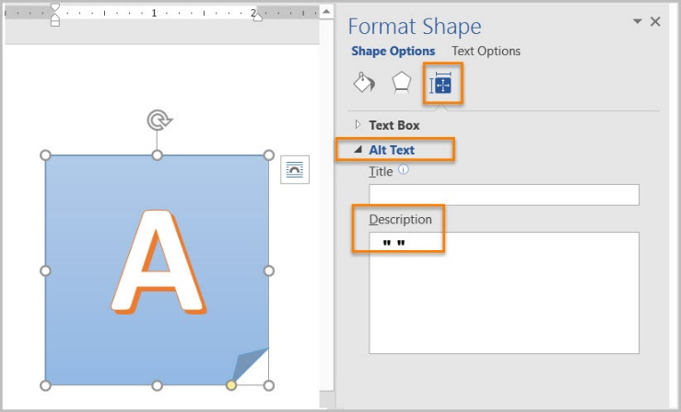

How to author for accessibility

Assistive technology cannot infer meaning from images and other objects. Images and other objects include pictures, images of text, images of tables, shapes, icons with hyperlinks, etc.

To enter “Alt Text,” select the image, object, or shape. “Right click” or “Shift+F10” and select “Format Picture (Note: could say Format Object, Format Shape, etc.)>Alt Text.” In the “Description” field, enter information that states the purpose (in as few words as possible while remaining clear) for a meaningful image or object or enter a space or two spaces between quotes for decorative objects. Then select “close.”

## Are images, objects, and text boxes in line with the text?

How to test

**Instruction:** Run the ‘Accessibility Checker’ through “File tab>Check for Issues>Check Accessibility”

**Figure 20:** Check Accessibility option in the Word Info Panel

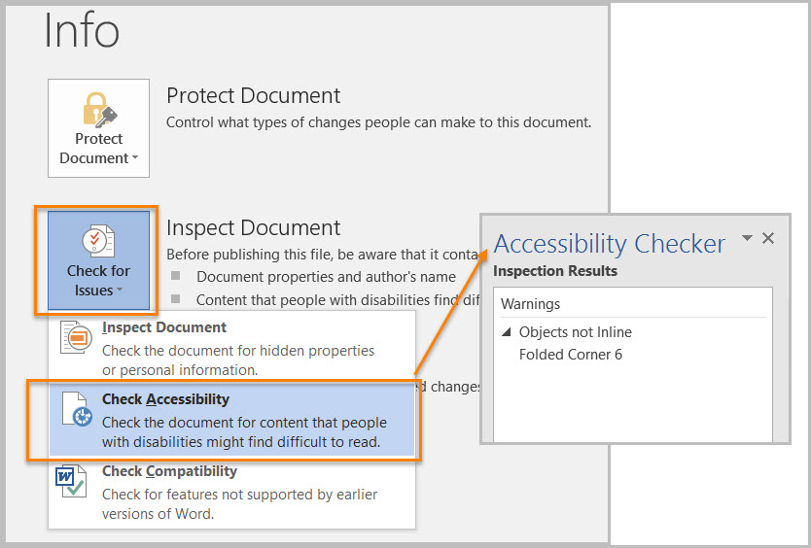

**Test:** Did you get any “Object not Inline” warnings? If so, the document fails this test.

How to author for accessibility

Screen readers and other assistive technologies cannot access or edit information in images, objects, and text boxes unless they are in line with text.

To place images, objects, and text boxes in line you:

* Select the image, object, or text box.
* Select “Picture (Note: could say Object, Shape, etc.) Tools>Format>Position>In Line with Text.”

**Figure 21:** Format tab Position menu option “In Line with Text” selected

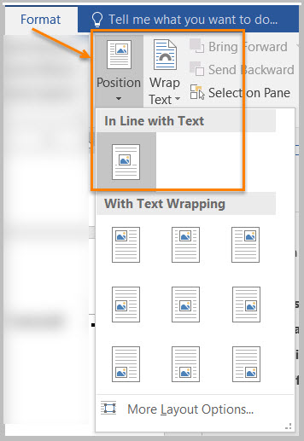

# Color Formatting

## Are colors and other visual characteristics that convey information also described with text?

How to test

Using only color or other visual characteristics such as size, shape, and location) to convey meaning will not provide comparable access to people who are blind, have low vision, or are colorblind.

**Instruction:** Find where you have used color and/or other visual characteristics to convey meaning such as green, yellow, red, etc.

**Test:** Is there text that conveys the meaning of the color or other visual characteristics? If not, the document fails this test.

How to author for accessibility

The following layout tables describe the progress for three projects using colors to symbolize the current project status. Adding text in addition to the color provides comparable information to users of assistive technology and people who are colorblind.

Use text to duplicate the meaning of the color or visual characteristics (such as size, shape, and location).

**Table 1:** Examples of Project status table using only color and color with text

| Project | Status |
| --- | --- |
| Project A |  |
| Project B |  |
| Project C |  |

| Project | Status |
| --- | --- |
| Project A | **On Time** |
| Project B | **At Risk** |
| Project C | **Late** |

## Is the contrast ratio between text and background sufficient?

**Note:** If the document text is black on white background (or close to it), you do not need to perform this test. This test requires the [Colour Contrast Analyser](https://www.paciellogroup.com/resources/contrastanalyser) (an external application).

How to test

Execute the Colour Contrast Analyser. Select “Download” (the application can be executed without downloading it onto your computer). Open the Colour Contrast Analyser. Drag the “Foreground eyedropper” icon over a sample of your text or image of text. Drag the “Background eyedropper” icon over a sample of your background color.

**Test:** Have you formatted with the correct color contrast ratio? If not, the document fails this test.

**Figure 22:** Examples of pass and fail results with the Colour Contrast Analyser

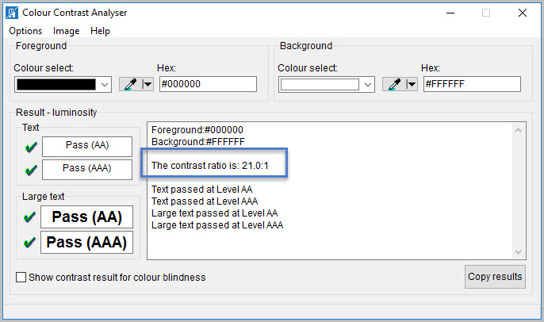  
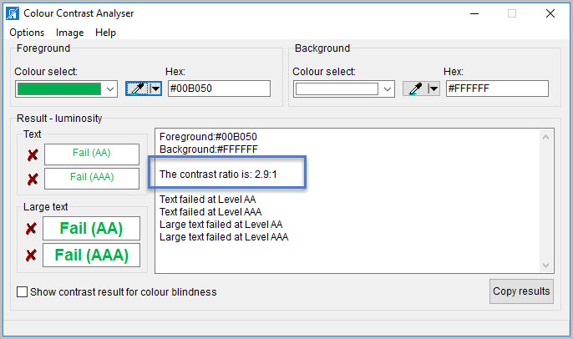

How to author for accessibility

People who are colorblind or have low vision will have comparable access if there is sufficient contrast between the text and the background. The contrast standards are:

**Table 2:** Table with contrast ratios for types and sizes of text

| Type or Size of Text | Contrast Ratio |
| --- | --- |
| Standard text (12 pt regular) | 4.5:1 |
| Large Text (14 pt bold or 18 pt regular) | 3:1 |
| Incidental text, text overlaid on images, and logotypes | Excluded from requirement |

Create content with text or images of text that use color or shading with sufficient color contrast. If the contrast ratio does not pass, then adjust your foreground or background until it does pass.

**Table 3:** Examples of good and insufficient color contrast ratios

| Good Color Contrast | Insufficient Color Contrast |
| --- | --- |
| White text on black background  ratio 21:0:1 | Dark gray text on black background  ratio 3.0:1 |
| Dark green text on yellow background  ratio 7.6:1 | Orange text on yellow background  ratio: 2.1:1 |
| Light blue text on dark blue background  ratio: 10.5:1 | Red text on dark blue background  ratio: 1.1:1 |
| white text on red background  ratio: 6.5:1 | Dark green text on red background  ratio: 1.3:1 |

# Miscellaneous

## Are there corresponding descriptions of your embedded files and are they accurate?

How to test

Note: If the document does not contain audio, video, or multimedia files, you do not need to perform this test.

**Instruction:** Activate the audio-only, video-only, or multimedia file.

**Test:** Is there an accurate and complete text transcript for multimedia files, text description for audio files, and synchronized caption and/or audio description for video files? If not, the document fails this test.

How to author for accessibility

If you embed an audio-only, video-only, or multimedia file that contains meaningful information into your MS Word document, you must also provide additional information so that individuals with disabilities have comparable access to the information.

* Audio Only
  + Accurate and complete transcript
* Video Only
  + Accurate and complete text description
* Synchronized media (audio and video)
  + Accurate and complete synchronized captions and audio descriptions

## Did you avoid forms while using MS Word 2016?

How to test

**Instruction:** Look for interactive Word form fields. Ignore blank table fields, blank spaces, or underlines that users fill in text are not interactive Word form fields. You are looking for the Word built-in form features that are interactive and can collect data. These Word form fields cannot be made accessible.

**Test**: Is the document free of all MS Word form fields? If not, the document fails this test.

How to author for accessibility

Forms created in Word cannot be made accessible for users of assistive technology and OMB certifications are likely required.

## Did you exclude flashing objects?

How to test

**Test:** Is the document free of all flashing objects? If not, the document fails this test.

How to author for accessibility

Create your content without using flashing objects. Flashing objects can cause seizures and should never be used.

Index of Figures

**Figure 1:** “Save As” options window 2

**Figure 2:** Restrict Editing pane options and protected enabled views 3

**Figure 3:** Matching headings displayed in Navigation Pane and document 4

**Figure 4:** Styles Pane and options window with Heading 1 Style selected 5

**Figure 5:** List option displayed under Bullets and Numbering 5

**Figure 6:** Paragraph tab displaying options for bulleted, numbered and multilevel lists 6

**Figure 7:** Number of Columns displayed under Section>Columns option 7

**Figure 8:** Columns menu set to Two columns option 7

**Figure 9:** Table Properties Table tab displaying Text wrapping set to “None” 8

**Figure 10:** Insert Table menu with a 4x3 table option selected 9

**Figure 11:** Korean Language displayed under Font>Language formatting option 10

**Figure 12:** Language window with Korean language option selected 10

**Figure 13:** Insert Hyperlink dialog window 11

**Figure 14:** Example of vital information in a header repeated in the body of the document 12

**Figure 15:** Complex table with merged and split cells 13

**Figure 16:** Table Properties with Repeat Header Row setting selected 13

**Figure 17:** Table Properties window with Text wrapping set to “None” 14

**Figure 18:** Format Picture – Alt Text Options 15

**Figure 19:** Decorative Content – alternative text using “quote space space quote.” 15

**Figure 20:** Check Accessibility option in the Word Info Panel 16

**Figure 21:** Format tab Position menu option “In Line with Text” selected 17

**Figure 22:** Examples of fail and pass results with the Colour Contrast Analyser 19

Index of Tables

**Table 1:** Examples of Project status table using only color and color with text 18

**Table 2:** Table with contrast ratios for types and sizes of text 20

**Table 3:** Examples of good and insufficient color contrast ratios 20